

*Operating Lease Support System Phase-2 Project*

*for*



***Functional Specification FC.AD.2.1***

***Maintenance Schedule Creation***

Revision 1.0

**PT. Berlian Sistem Informasi**

KTB Annex Bld. 4th Floor, Jl. Jend. A. Yani. Pulomas,

Tel. +62 21 4786 7575 (Hunting) Fax. +62 21 4714964 www.bsi.co.id

Document Control

|  |  |
| --- | --- |
| **Author** | Dimas Oktarianto |
| **File Name** |  |
| **Path** | \OPRLEASE-P2\Deliverable Based-2\Working\04.Design\04.02 Functional Spesification\ |
| **Number of Pages** |  |

Revision History

|  |  |  |  |
| --- | --- | --- | --- |
| **Date** | **Revision** | **Description** | **Author** |
| 9/11/2015 | 0.0 | Initial Creation | Dimas Oktarianto |
| 17/12/2015 | 0.1 | QCO Review :   * Revise Screen Date / Time into Date (page 11). * Revise Shorting into sorting (page 19). * Revise Source Data Structure into Tb_OPL_Branch.BranchShortName (Page 20). * Revise Data Type from boleean into boolean (Page 21). | Dimas Oktarianto |
| 04/01/2016 | 0.2 | QCO Review :   * Revise Data Type for KM from Integer to Decimal (Page 20). * Revise Distribution list and document approval | Dimas Oktarianto |
| 12/01/2016 | 1.0 | 1st Baseline | Dimas Oktarianto |

Distribution List

|  |  |  |
| --- | --- | --- |
| Name | Organization | Roles |
| Mr. Setsuya Yoshino | Dipo Star Finance, PT | DSF Project Owner |
| Mr. Yutaro Sanada | Dipo Star Finance, PT | DSF Project Director |
| Mr. Shinji Hosokawa | Dipo Star Finance, PT | DSF Project Director |
| Mr. Shinya Tsukamoto | Dipo Star Finance, PT | DSF IT Advisor |
| Mr. Ahmad Fikri | Dipo Star Finance, PT | DSF IT Advisor |
| Mr. Roby Wijaya | Dipo Star Finance, PT | DSF PMO |
| Mr. Abdul Somad | Dipo Star Finance, PT | DSF Biz. Operation Leader |
| Mr. Mukhlis Ibrahim | Dipo Star Finance, PT | DSF IT Operation Leader |
| Mr. Delta Riangga | Dipo Star Finance, PT | DSF Key User |
| Mr. Mochamad Idris | Dipo Star Finance, PT | DSF Key User |
| Mrs. Herni Hembang | Dipo Star Finance, PT | DSF Key User |
| Mr. Junaidi Didy | Dipo Star Finance, PT | DSF Key User |
| Mr. Dedi Supriyadi | Dipo Star Finance, PT | DSF Key User |
| Mrs. Elke Hilviana | Dipo Star Finance, PT | DSF Key User |
| Mr. Daiki Kamada | Berlian Sistem Informasi, PT | BSI Project Director |
| Mr. Yoshinori Kawahara | Berlian Sistem Informasi, PT | BSI IT Advisor |
| Mr. Satoshi Koibuchi | Berlian Sistem Informasi, PT | BSI IT Advisor |
| Mr. Grand Zah Putra | Berlian Sistem Informasi, PT | BSI Project Manager |
| Mr. Raymond | Berlian Sistem Informasi, PT | BSI Technical Leader |
| Mr. Dimas Oktarianto | Berlian Sistem Informasi, PT | BSI Business Analyst |

Document Approval

By signing this document I acknowledge I have read the document and give the Project Management Team approval to proceed.

|  |  |  |  |
| --- | --- | --- | --- |
| Role | Name | Signature | Date |
| DSF Project Director | Mr. Yutaro Sanada |  |  |
| DSF Project Director | Mr. Shinji Hosokawa |  |  |
| DSF IT Advisor | Mr. Shinya Tsukamoto |  |  |
| DSF IT Advisor | Mr. Ahmad Fikri |  |  |
| DSF PMO | Mr. Roby Wijaya |  |  |
| DSF DSF Biz. Operation Leader | Mr. Abdul Somad |  |  |
| DSF IT Operation Leader | Mr. Mukhlis Ibrahim |  |  |
| BSI Project Director | Mr. Daiki Kamada |  |  |
| BSI Project Manager | Mr. Grand Zah Putra |  |  |
| BSI Technical Leader | Mr. Raymond |  |  |
| BSI Business Analyst | Mr. Dimas Oktarianto |  |  |

Table of Contents

Document Control 2

Revision History 2

Distribution List 3

Document Approval 4

1 Introduction 6

1.1 Purpose 6

1.2 Scope 6

1.3 Definitions, Acronyms, and Abbreviations 6

1.4 References 6

2 Configuration 6

3 Process Specification: AD.2.1 Maintenance Schedule Creation 7

3.1 Purpose 7

3.2 Screen of Configuration Access 7

3.3 Screen Functionality 7

3.4 Operation Flow 7

3.5 Screen Detail 9

3.6 Component Screen Functionality 10

3.7 Operation Description 12

3.8 Data Structure 20

3.9 Screen Item List 21

3.10 Entity Relationship Diagram 23

1. Introduction
   1. Purpose

Functional Specification is a document to describe the detail of functions system which includes screen design and logic formula. This document will be used for system development.

* 1. Scope

Functional Specification Document contains screen design, screen functionality, process flow, and data structure of AD.2.1 Maintenance Schedule Creation.

Here are the scope for AD.2.1 Maintenance Schedule Creation :

1. **AD.2.1.1 View List of Maintenance Agreement**

To view List Maintenance of Unit based on Agreement, Purchase Order, and Unit Management.

1. **AD.2.1.2 Create Schedule**

Create Schedule for new replacement unit.

1. **AD.2.1.3 Update Schedule**

Update schedule Maintenance of unit.

Output from this function is :

1. RPT.AD.2.2. Report Monthly Maintenance Unit
   1. Definitions, Acronyms, and Abbreviations

List of definitions that are used in this document :

1. WO = Work Order.
2. MU = Maintenance Unit.
3. OPL = Operating Lease.
4. BAST = Berita Acara Serah Terima / Handover Report.
   1. References

This functional specification document refers to **“To Be Design” BSI Unit/ Vehicle Maintenance Process**, module:

1. AD.2.1 Maintenance Schedule Creation.
2. Configuration

N/A

1. Process Specification: AD.2.1 Maintenance Schedule Creation
   1. Purpose

Screen of Maintenance Schedule Creation will be used by PIC Maintenance to monitor and update schedule maintenance of unit. This Screen Function consist of view list of maintenance agreement, create schedule, and update schedule.

This function covered by **“Maintenance Schedule Creation”** screen.

* 1. Screen of Configuration Access

Here are the access rights for **“Maintenance Schedule Creation”** screen users:

|  |  |  |  |  |
| --- | --- | --- | --- | --- |
| ***User*** | ***Create*** | ***Read*** | ***Update*** | **Authorization** |
| PIC Maintenance | - | V | V | V |
| Admin | - | V | - | V |

Legend: V = Have the Access

Note:

1. Create : related to create maintenance schedule.
2. Read: related to read display data List of Maintenance Agreement
3. Update: related to update schedule maintenance of unit.
4. Authorization: related to access screen.
   1. Screen Functionality
5. Display List of Maintenance Agreement.
6. Create Schedule for New Replacement Unit.
7. Update Schedule Maintenance of Unit.
   1. Operation Flow

Below is operation flow for Maintenance Schedule Creation process referring to **To Be Design Document Unit/ Vehicle Maintenance**, AD.2.1. Maintenance Schedule Creation:

|  |  |
| --- | --- |
| **PIC PC** | **Process** |
|  | AllList.png  Agreement  (OPL Agreement)  Billing Collection  (TB_Billing)  Unit Management  (TB_MGT)  Service History Inquire  (OPLServiceHistory)  Note:  Source  Output & Input |

Below is operation flow of ‘Maintenance Schedule Creation’ which is used to input and update schedule for replacement unit by PIC Maintenance:

|  |  |
| --- | --- |
| **PIC PC** | **Process** |
|  | AllList.png  Note:  Source  Output & Input    Unit Maintenance  (TB_MTN_Monitoringschdl)  Agreement  (OPL Agreement)    Billing Collection  (TB_Billing)  Unit Management  (TB_MGT)  Service History Inquiry  (OPLServiceHistory) |

* 1. Screen Detail
* Screen design of ‘List of maintenance agreement’, which will be used as an initial screen for Monitoring schedule maintenance of unit and also is used as input and update schedule for Replacement Unit.

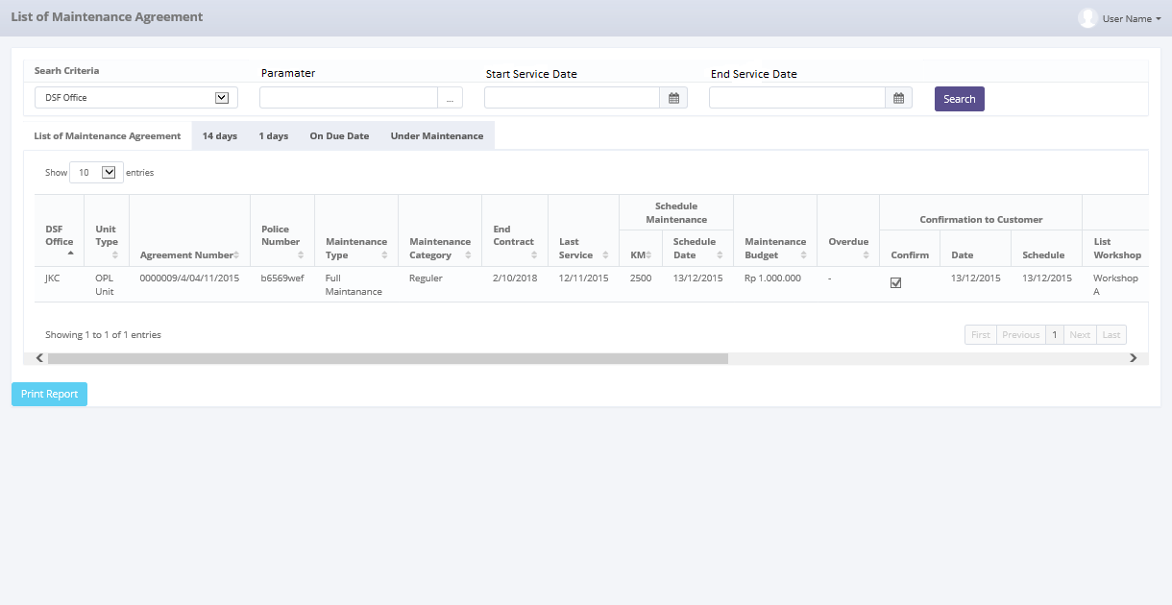

*Screen 1. List of Maintenance Agreement*

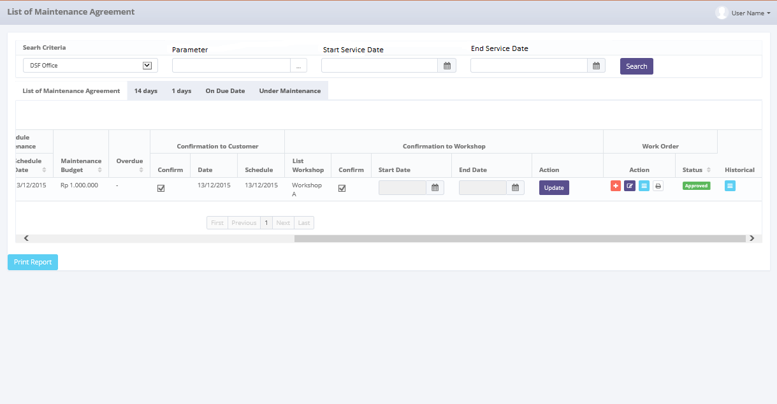

*Screen 2. List of Maintenance Agreement*

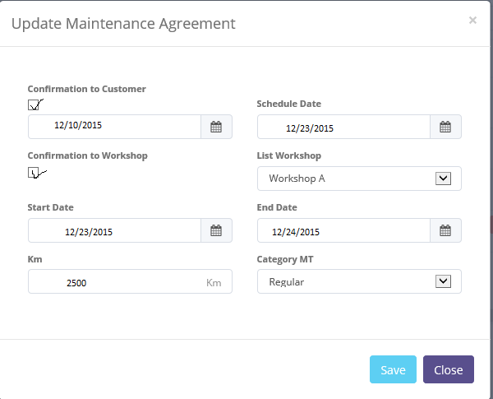

*Screen 3. Pop up Confirmation*

* 1. Component Screen Functionality

Here are the screen functions from each component in Maintenance Schedule Creation screen:

|  |  |  |  |
| --- | --- | --- | --- |
| ***No*** | ***Component*** | ***Name*** | ***Function*** |
| **Header** | | | |
| 1. | Label | List of Maintenance Agreement | List of Maintenance Agreement title |
| **Search Criteria** | | | |
| 2. | Drop down box | Search Criteria | To Select Category for searching maintenance data |
| 3. | Text Field | Parameter | To input parameter for searching maintenance data |
| 4. | Date Picker | Start Service Date | To input start Service Date based on update date when submit maintenance data |
| 5. | Date Picker | End Service Date | To input end Service Date based on update date when submit maintenance Data |
| 6. | Button | Search | To search maintenance data based on selected criteria |
| **List of Maintenance Agreement** | | | |
| 7. | Drop down box | Show Entry | To select number of row data that will be displayed in one screen (paging) |
| 8. | Button | Sort | To sort data on table list of Maintenance, ascending and descending |
| 9. | Label | DSF Office | To display DSF Branch Office |
| 10. | Label | Unit Type | To display type of unit, OPL unit or replacement unit |
| 11. | Label | Agreement Number | To display agreement |
| 12. | Label | Police Number | To display Police number of unit |
| 13. | Label | Maintenance Type | To display maintenance type of unit |
| 14. | Label | Maintenance Category | To display category maintenance of unit |
| 15. | Label | End Contract | To display maintenance end contract of unit |
| 16. | Label | Last Service | To display last service date of unit |
| 17. | Label | Schedule Maintenance | To display schedule maintenance |
| 18. | Label | KM | To display KM of Unit |
| 19. | Label | Schedule Date | To display date of maintenance |
| 20. | Label | Maintenance Budget | To display budget maintenance of unit |
| 21. | Label | Overdue | To display overdue budget of unit |
| 22. | Label | Action | To display action for Maintenance data |
| 23. | Label | Confirm | To display Confirmation to Customer |
| 24. | Checkbox | Confirm | To Show already confirm to customer |
| 25. | Date | Date | To display date from system |
| 26. | Date | Schedule | To display request schedule from customer |
| 27. | Label | Confirm | To display Confirmation to Workshop |
| 28. | Dropdown Box | Workshop | To select workshop |
| 29. | Checkbox | Confirm | To Show already confirm to workshop |
| 30. | Date | Start Date | To display start date |
| 31. | Date | End Date | To display end date |
| 32. | Button | Update | To Update schedule, KM, Confirmation to Workshop, Confirmation to Customer |
| 33. | Label | Work Order | To display button work order |
| 34. | Button | Create Work Order | To create Work Order |
| 35. | Button | Edit Work Order | To Edit Work Order |
| 36. | Button | Print Work Order | To Print Work Order |
| 37. | Button | View List WO | To View List of Work Order |
| 38. | Label | Status | To Display Last Status Work Order |
| 39. | Button | Submit | To go into menu service history inquiry |
| 40. | Label | Showing N to M of X entries | Displaying Maintenance data sequence and the total of maintenance data |
| 41. | Link | First Page | To display first entries page of maintenance data |
| 42. | Link | Previous Page | To display the previous entries page of maintenance data |
| 43. | Link | Page Number | Displaying the Page Number of the List |
| 44. | Link | Next Page | To display the next entries page of maintenance data |
| 45. | Link | Last Page | To show the last page entry |
| **Footer** | | | |
| 46. | Button | Print Report | To Print the report from list of maintenance agreement |

Here are the screen functions from each component in Pop Up Maintenance Schedule Creation screen :

|  |  |  |  |
| --- | --- | --- | --- |
| ***No*** | ***Component*** | ***Name*** | ***Function*** |
| **Header** | | | |
| 1. | Label | Update Maintenance Agreement | Update Maintenance Agreement title |
| **Update Maintenance Agreement** | | | |
| 2. | Label | Confirmation to Customer | To display Confirmation to Customer |
| 3. | Checkbox | Confirmation to Customer | To checklist confirmation to customer |
| 4. | Date Picker | System Date | To display System Date |
| 5. | Date Picker | Schedule Date | To Input Request Date from Customer |
| 6. | Label | Confirmation to Workshop | To display Confirmation to Workshop |
| 7. | Label | Maintenance Category | To display category maintenance of unit |
| 8. | Checkbox | Confirmation to Customer | To checklist confirmation to workshop |
| 9. | Dropdown Box | List Workshop | To display list workshop |
| 10. | Date Picker | Start Date | To input start date for maintenance |
| 11. | Date Picker | End Date | To input end date for maintenance |
| 12. | Text Field | KM | To Input Actual KM |
| 13. | Text Field | Category MT | To input category maintenance |
| **Footer** | | | |
| 14. | Button | Save | To save the update |
| 15. | Button | Close | To Close Pop Up |

* 1. Operation Description

|  |  |  |
| --- | --- | --- |
| **No.** | **Operation Name** | **Description** |
| 1 | Initial view of List of Maintenance Agreement | The screen for List of Maintenance Agreement:   1. Component Status;  |  |  |  |  | | --- | --- | --- | --- | | Component | Name/Caption | Status | Remark | | Drop down box | User Name | Active |  | | Drop down | Search Criteria | Active |  | | Field Text | Parameter | Active |  | | Date Picker | Start Period | Active |  | | Date Picker | End Period | Active |  | | Button | Search | Active |  | | Drop down box | Show Entries | Active | As initial by default number of show entries list that will be display is 10 | | Button | Sort | Active |  | | Label | DSF Office | Not Active |  | | Label | Unit Type | Not Active |  | | Label | Agreement Number | Not Active |  | | Label | Police Number | Not Active |  | | Label | Maintenance Type | Not Active |  | | Label | Maintenance Category | Not Active |  | | Label | End Contract | Not Active |  | | Label | Last Service | Not Active |  | | Label | Schedule Maintenance | Not Active |  | | Label | KM | Not Active |  | | Label | Schedule Date | Not Active |  | | Label | Maintenance Budget | Not Active |  | | Label | Overdue | Not Active |  | | Label | Confirmation to Customer | Not Active |  | | Checkbox | Confirm | Not Active | Active when view in 14 tab and 1 day tab | | Date | System Date | Active | Automatic from system date | | Date | Request Date | Not Active | Active when view in 14 tab and 1 day tab | | Button | Next Page | Active | Active depending on the current entry | | Button | Last Page | Active | Active depending on the current entry | | Label | Confirmation to Workshop | Not Active |  | | Dropdown Box | Workshop | Active | Show in Pop Up Menu Screen | | CheckBox | Confirm | Active | Show in Pop Up Menu Screen | | Date Picker | Start Date | Active | Show in Pop Up Menu Screen | | Date Picker | End Date | Active | Show in Pop Up Menu Screen | | Button | Update | Active | Active depending on unit type and when view in 14 tab and 1 day tab | | Label | Work Order | Not Active |  | | Button | Create Work Order | Not Active | Active depending on unit type and when view in 14 tab and 1 day tab | | Button | Edit Work Order | Not Active | Active depending on unit type and when view in 14 tab and 1 day tab | | Button | Print Work Order | Not Active | Active depending on unit type and when view in 14 tab and 1 day tab | | Button | View Work Order | Not Active | Active depending on unit type and when view in 14 tab and 1 day tab | | Label | Status | Not Active |  | | Field Text | Status | Not Active | Mandatory Field last status Work Order | | Button | Submit | Not Active | Active when view 14 day tab, 1 day tab, and on due date | | Label | Showing N to M of X entries | Not Active |  | | Link | First Page | Active | Active depending on the current entry | | Link | Previous Page | Active | Active depending on the current entry | | Link | Page Number | Not Active |  | | Link | Next Page | Active | Active depending on the current entry | | Link | Last Page | Active | Active depending on the current entry | | Button | Print Report | Active |  | |  |  |  |  | |
| 2 | Display List of Maintenance Agreement | Input:   1. Access menu OLSS 2. Select menu Maintenance 3. Select sub menu view list of maintenance agreement 4. Select number of show list entries : 10, 25, 50, and 100     Process:   1. System will displays data on List of maintenance agreement with upcoming service date in ascending order. 2. Data that will be displayed are Agreement data with maintenance based on the Tb_OPL_Branch, Agreement (OPL_Agreement.AgreementNumber, OPL_Agreement.MaintenanceType, EndPeriodDate), Maintenance (OPLServiceHistory.IsIregular, ServiceDate, MaintenanceBudget), Unit Management (TB_MGT.UnitType) (TB_MGT.PoliceNumber), Billing (TB.Billing.Overdue). 3. Work Order Data on Field work order displayed the latest Status WO. 4. Based on **Screen 1. List of Maintenance Agreement**, information related to Maintenance Agreement that will be displayed automatically are: 5. DSF Office ( source : Tb_MTN_Monschdl.DSFOffice ) 6. Unit Type ( source : Tb_MTN_Monschdl.UnitType ) 7. Agreement Number ( source : Tb_MTN_Monschdl.AgreementNumber ) 8. Police Number ( source : Tb_MTN_Monschdl.PoliceNumber ) 9. Maintenance Type ( source : Tb_MTN_Monschdl.MaintenanceType ) 10. End Contract ( source : Tb_MTN_Monschdl.EndContract ) 11. Last Service ( source : Tb_MTN_Monschdl.LastService ) 12. KM ( source : Tb_MTN_Monschdl.KM ) 13. Schedule Date ( source : Tb_MTN_Monschdl.ScheduleDate ) 14. Maintenance Budget ( source : Tb_MTN_Monschdl.MaintenanceBudget ) 15. Overdue ( source : Tb_MTN_Monschdl.Overdue ) 16. System will display data row based on selected show number entries.   Output:   1. Display list of all Agreement with maintenance data 2. System will displays data on List of maintenance agreement with upcoming service date in ascending order.   Alternative:  N/A |
| 3 | Searching List of Maintenance Agreement at List of Maintenance Agreement | Input:   1. Access menu OLSS 2. Select menu Maintenance 3. Select sub menu view list of maintenance agreement 4. Select Search Criteria Drop down boxand click among these:  |  |  | | --- | --- | | **Criteria Searching** | **Constraint Input** | | Police Number | varchar | | Agreement Number | varchar | | DSF Office | varchar | | Unit Type | varchar | | Maintenance Type | varchar | | Maintenance Category | varchar | | End Contract | Date | | Last Service | Date | | KM | Number | | Schedule Date | Date | | Maintenance Budget | Number |  1. Select Start and End date period to filter based on the End Contract, Last Service, Schedule Date.   Constraint :   * 1. End Period can not be less than Start Period (the End Period will be locked for the date before Start Date).   2. Start Period can not be less than End Period (the Start Period will be locked for the date after End Date)   3. Default Searching period for list of maintenance category based on Service Schedule Date.  1. Click Search button 2. Select number of show list entries : 10, 25, 50, and 100     Process:   1. User can only choose one search criteria to be searched 2. When user click search button, system will displays data on List of Maintenance Agreement based on the selected criteria searching. Formula: 3. If user input Criteria Searching, Criteria Searching parameter, Start Date, and End Date period, system displays data based on selected criteria searching on selected range end contract, Last Service, Schedule Date. 4. If user input both of Criteria Searching, Criteria Searching parameter and Start Date, system displays data based on selected criteria searching start from selected Schedule Date until the latest Schedule date. 5. If user input both of Criteria Searching, Criteria Searching parameter and End Date, system displays data based on selected criteria searching start from the oldest Schedule date until selected update date. 6. If user input Criteria Searching and its parameter only, system displays all of the list of maintenance agreement data based on the criteria searching only. 7. Data that will be displayed are data based on the newest Maintenance agreement date (TB_MTN_Monschdl). 8. Based on **Screen 1. List of Maintenance Agreement**, informations related to Maintenance Agreement that will be displayed automatically are: 9. DSF Office ( source : Tb_MTN_Monschdl.DSFOffice ) 10. Unit Type ( source : Tb_MTN_Monschdl.UnitType ) 11. Agreement Number ( source : Tb_MTN_Monschdl.AgreementNumber ) 12. Police Number ( source : Tb_MTN_Monschdl.PoliceNumber ) 13. Maintenance Type ( source : Tb_MTN_Monschdl.MaintenanceType ) 14. End Contract ( source : Tb_MTN_Monschdl.EndContract ) 15. Last Service ( source : Tb_MTN_Monschdl.LastService ) 16. KM ( source : Tb_MTN_Monschdl.KM ) 17. Schedule Date ( source : Tb_MTN_Monschdl.ScheduleDate ) 18. Maintenance Budget ( source : Tb_MTN_Monschdl.MaintenanceBudget ) 19. Overdue ( source : Tb_MTN_Monschdl.Overdue ) 20. System will display data row based on selected show number entries   Output:   1. Display list of all Maintenance Agreement data based on the search result in descending order.   Alternative:  N/A |
| 4 | Print Report | Input:   1. Access menu OLSS 2. Select menu Maintenance 3. Select sub menu view list of maintenance agreement 4. Select Search Criteria Drop down box and click among these:  |  |  | | --- | --- | | **Criteria Searching** | **Constraint Input** | | DSF Office | Varchar | | Unit Type | Varchar | | Agreement Number | Varchar | | Police Number | Varchar | | Maintenance Type | varchar | | Maintenance Category | varchar | | End Contract | Date | | Last Service | Date | | KM | Number | | Schedule Date | Date | | Maintenance Budget | Number | | Overdue | Number |  1. Select Start and End date period to filter based on the Schedule Date.     Constraint:   * 1. End Period can not be less than Start Period (the End Period will be locked for the date before Start Date)   2. Start Period can not be less than End Period (the Start Period will be locked for the date after End Date)  1. Click Search button . 2. Click Print Report button     Process:   1. User can view list of maintenance agreement data which will be printed, in list of maintenance search result list. 2. System will display list of maintenance Agreement in Ms.Excel with file name as below format:   List of Maintenance Agreement Report_MMddyyyy_hhmm  Then User can convert that file into PDF format and save file into selected path  Note :  MMddyyyy → month,day,year when report printed  hhmm → hours, minute when report printed   1. Informations related to Maintenance that will be printed are:    1. DSF Office    2. Unit Type    3. Agreement Number    4. Police Number    5. Maintenance Type    6. Maintenance Category    7. End Contract    8. Last Service    9. KM    10. Schedule Date    11. Maintenance Budget    12. Overdue 2. Maintenance data will be sorted based on Maintenance date service at Maintenance Report   Output:   1. Printed out report list **RPT.AD.2.2 List Maintenance Report**   Alternative:  N/A |
| 5 | Input and update schedule for replacement unit | Input:   1. Access menu OLSS 2. Select menu Maintenance 3. Select sub menu List of Maintenance 4. Choose replacement unit on unit type 5. Click Update button for Update schedule maintenance on schedule date, Confirmation to Customer, Confirmation to Workshop, Actual Mileage.     Constraint :   * 1. Clicking the button will trigger a pop up screen for update schedule.      * 1. Checklist Confirmation to Customer to enabled schedule date and Choose the date for replacement unit.   2. Checklist Confirmation to Workshop, Choose Workshop, Pick Start Date and End date based on workshop confirmation.   3. Update the actual mileage and choose category Maintenance. Actual Mileage inputted with number. When user click onto field there is a hint “Input with Number”.   4. The date cannot be input after end contract date.   5. The date cannot be input before last service  1. Click Save button to save the new schedule date maintenance for replacement unit which can be edited later.     Process:   1. System will sort data by unit type. 2. PIC Maintenance check Replacement Unit schedule. 3. PIC Maintenance click update schedule maintenance for replacement unit if unit KM has reach condition for maintenance then pop up for update shown to input the schedule. 4. When user click button save, after that system will save updated schedule maintenance data. After save there will be notification shown “**Success ! Maintenance Unit has been updated**”   Output:   1. Update Schedule for replacement unit. 2. Data will be saved to table TB_MTN_Monschdl   Alternative:  N/A |

* 1. Data Structure

**Tb_MTN_Monschdl**

|  |  |  |  |  |  |  |
| --- | --- | --- | --- | --- | --- | --- |
| *Field Name* | *Data Type* | *Length* | *Source* | *Remarks* | *Nullable* | *Mandatory* |
| DSFOffice | *Varchar* | *5* | Tb_OPL_Branch.BranchShortName | ***Foreign Key***  *Where Tb_MTN_Monschdl.DSFOffice = Tb_OPL_Branch.IdTb_OPL_Branch* | No | Yes |
| UnitType | *Varchar* | *100* | Tb_OPL_Unit.UnitType | ***Foreign Key***  *Where Tb_MTN_Monschdl.UnitType = Tb_OPL_Unit.UnitType* | No | Yes |
| AgreementNumber | *Varchar* | *50* | OPLAgreement.  AgreementNumber | ***Foreign Key***  *Where Tb_MTN_Monschdl.AgreementNumber = OPLAgreement.*  *AgreementNumber* | No | Yes |
| PoliceNumber | *Varchar* | *10* | Tb_MGT_BASTSupCust.PoliceNumber | ***Primary Key***  *Where Tb_MTN_Monschdl.PoliceNumber =* Tb_MGT_BASTSupCust.PoliceNumber | No | Yes |
| MaintenanceType | *Varchar* | *20* | OPLAgreementDetails.MaintenanceType | ***Foreign Key***  *Where*  *Tb_MTN_Monschdl.MaintenanceType =* *OPLAgreementDetails.MaintenanceType* | No | Yes |
| Maintenance Category | *Varchar* | *20* | TB_MTN_Monitoringschdl.MaintenanceCategory |  | No | Yes |
| EndContract | *Datetime* | *n/a* | OPLServiceHistory.ServiceDate | ***Foreign Key***  *Where*  *Tb_MTN_Monschdl.EndConftract =* *OPLServiceHistory.ServiceDate* | No | Yes |
| LastService | *Datetime* | *n/a* | OPLServiceHistory.ServiceDate | ***Foreign Key***  *Where*  *Tb_MTN_Monschdl.LastService =* *OPLServiceHistory.ServiceDate* | No | Yes |
| KM | *Decimal* | *5.0* | OPLMaintenanceCondition_History_Dtl.PeriodicMaintenanceKM | ***Foreign Key***  *Where*  *Tb_MTN_Monschdl.KM =* *OPLMaintenanceCondition_History_Dtl.PeriodicMaintenanceKM* | No | Yes |
| ScheduleDate | *Datetime* | *n/a* | OPLServiceHistory.ServiceDate | ***Foreign Key***  *Where*  *Tb_MTN_Monschdl.ScheduleDate =* *OPLServiceHistory.ServiceDate* | No | Yes |
| MaintenanceBudget | *Decimal* | *18.3* | OPLServiceHistorySum.MaintenanceBudget | ***Foreign Key***  *Where*  *Tb_MTN_Monschdl.MaintenanceBudget =* *OPLServiceHistorySum.MaintenanceBudget* | No | Yes |
| Overdue | *Decimal* | *18.3* | Tb_Bill_PayScheduleDetail.IsOverdue | ***Foreign Key***  *Where*  *Tb_MTN_Monschdl.Overdue =* *Tb_Bill_PayScheduleDetail.IsOverdue* | No | Yes |
| IsConfirmation | *Boolean* | *n/a* | TB_MTN_Monschdl.IsConfirmation |  | No | No |
| Schedule | *Datetime* | *n/a* | TB_MTN_Monschdl.Schedule |  | No | No |
| Workshop | *Varchar* | *100* | TB_MTN_Monschdl.Workshop | ***Foreign Key***  *Where*  *Tb_MTN_Monschdl.Workshop =* *Supplier.IdSupplier* | No | Yes |
| WorkshopLocation | *Varchar* | *50* | TB_MTN_Monschdl.Workshop | ***Foreign Key***  *Where*  *Tb_MTN_Monschdl.Workshop =* *Supplier.IdSupplier* | No | Yes |
| IsWorkshop | *Boolean* | *n/a* | TB_MTN_Monschdl.IsWorkshop |  | No | No |
| Start Date | *Datetime* | *n/a* | TB_MTN_Monschdl.StartDate |  | No | No |
| End Date | *Datetime* | *n/a* | TB_MTN_Monschdl.EndDate |  | No | No |

* 1. Screen Item List

**RPT.AD.2.2 Report Monthly Maintenance Unit**.

|  |  |  |  |  |
| --- | --- | --- | --- | --- |
| *No.* | *Content* | *Description* | *Source* | *Remarks* |
| 1 | List of Maintenance Unit | Default Label | Static |  |
| 2 | Period | Period Monthly Report | Based on selected Start Date and End Date that already select by User when print Report | *Format display on report:*  *MM/dd/YYYY* |
| 3 | Page | Number of Report Page | Automatically count by number of page | *&[page] of &[total page]* |
| 4 | Printed By | Printed by | Sys.Username | User Name is the one who login to system |
| 5 | Printed Date | Printed Date | Use date at server when button Print Report is Clicked | *Format display on report:*  *MM/dd/YYYY* |
| 6 | DSF Office | Branch of the maintenance data | TB_MTN_Monitoringschdl.DSFOffice |  |
| 7 | Unit Type | Unit Type | TB_MTN_Monitoringschdl.UnitType |  |
| 8 | Agreement Number | Agreement Number | TB_MTN_Monitoringschdl.AgreementNumber |  |
| 9 | Police Number | Police Number | TB_MTN_Monitoringschdl.PoliceNumber |  |
| 10 | Maintenance Type | Maintenance Type | TB_MTN_Monitoringschdl.MaintenanceType |  |
| 11 | Maintenance Category | Maintenance Category | TB_MTN_Monitoringschdl.MaintenanceCategory |  |
| 12 | End Contract | End Contract | TB_MTN_Monitoringschdl.EndContract |  |
| 13 | Last Service | Last Service | TB_MTN_Monitoringschdl.LastService |  |
| 14 | KM | *Unit KM* | TB_MTN_Monitoringschdl.KM |  |
| 15 | Schedule Date | *Schedule Maintenance* | TB_MTN_Monitoringschdl.ScheduleDate |  |
| 16 | Maintenance Budget | *Unit Maintenance Budget* | TB_MTN_Monitoringschdl.MaintenanceBudget |  |
| 17 | Overdue | *Overdue Payment* | TB_MTN_Monitoringschdl.Overdue |  |

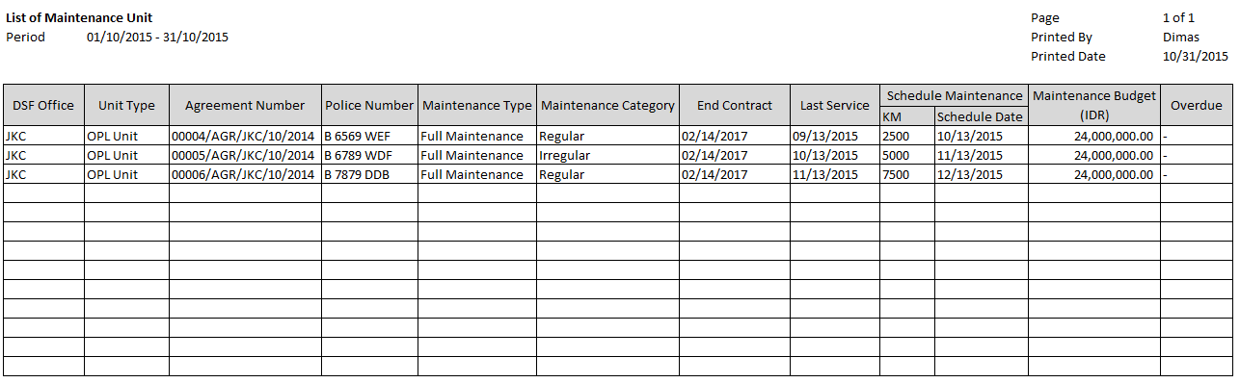

4

5

3

2

1

14

13

12

11

10

9

17

16

15

8

7

6

* 1. Entity Relationship Diagram

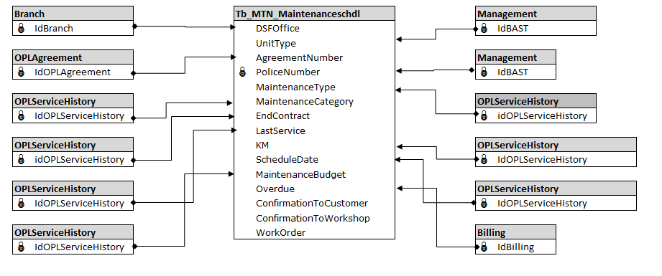

**APPENDIX**

Configuration Access for Maintenance Schedule Creation:

|  |  |  |  |  |  |  |  |
| --- | --- | --- | --- | --- | --- | --- | --- |
| **User** | **Branch** | **Functions** | | | | | |
| **Display List** | **Create** | **Edit** | **View** | **Print Form** | **Print Report** |
| PIC Maintenance HO/Branch | One | V | V | V | V | V | V |
| Area |  |  |  |  |  |  |
| All |  |  |  |  |  |  |
| Marketing Officer | One | V |  |  | V | V | V |
| Area |  |  |  |  |  |  |
| All |  |  |  |  |  |  |
| Head of Branch | One | V |  |  | V | V | V |
| Area |  |  |  |  |  |  |
| All |  |  |  |  |  |  |
| Head of Department | One |  |  |  |  |  |  |
| Area |  |  |  |  |  |  |
| All | V |  |  | V | V | V |
| Regional Manager | One |  |  |  |  |  |  |
| Area | V |  |  | V | V | V |
| All |  |  |  |  |  |  |
| Advisor | One |  |  |  |  |  |  |
| Area |  |  |  |  |  |  |
| All | V |  |  | V | V | V |
| Director | One |  |  |  |  |  |  |
| Area |  |  |  |  |  |  |
| All | V |  |  | V | V | V |
| President Director | One |  |  |  |  |  |  |
| Area |  |  |  |  |  |  |
| All | V |  |  | V | V | V |
| Shareholder's Meeting | One |  |  |  |  |  |  |
| Area |  |  |  |  |  |  |
| All | V |  |  | V | V | V |
|  |  |  |  |  |  |  |  |
| **Legend:** |  |  |  |  |  |  |  |
| V = Have the access |  |  |  |  |  |  |  |